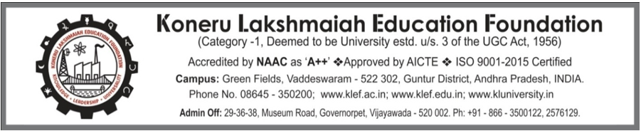

**CLEAN INDIA CAMPAIGN 2.0 2022**

**Date of Event: 19-10-2022**

**Location of Event: P&T Colony, Bandlaguda, Hyderabad**

**Number of Persons Attending: 122**

**Faculty Coordinator:** **Dr. Mardanpally Mallesh**

**CONDUCTED BY: National Service Scheme**

Today on 19 November 2022 Clean India program was held by NSS. This program was held mainly to collect plastic. This program was held in P&T Colony, Bandlaguda. About 122 members from both Y21 and Y22 participated in this event. This shows the active participation of the KLH team. All worked jointly to make their surroundings clean.

We reached the area by 10:15 am. We were given gloves, masks, to maintain sanitation, and covers to collect the plastic. Everyone made teams and collected plastic. Around 11 am everyone gathered with the plastic they collected. A huge weight of 225kg of plastic was collected in total which was tremendous. We had Mr. Naresh Kumar, the Sanitary Inspector of Bandlaguda present on behalf of the municipal commissioner. He addressed the gathering regarding the importance of cleanliness in our surroundings. He told me how to segregate the waste into dry, wet, and harmful which was very useful.

The whole campaign gave us good exposure to how our surroundings should be. Everyone came as one to make this event successful and victorious.

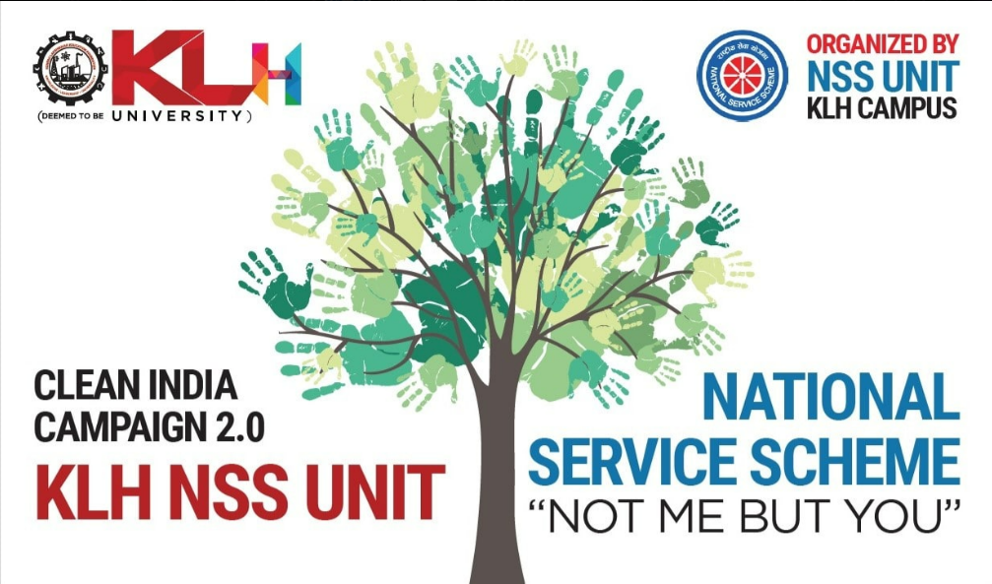

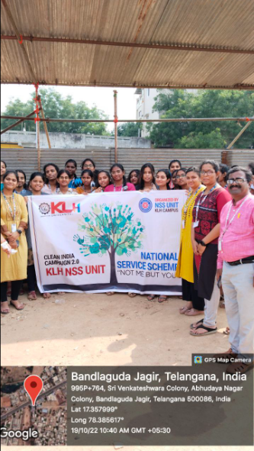 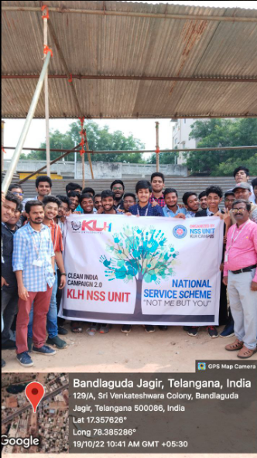

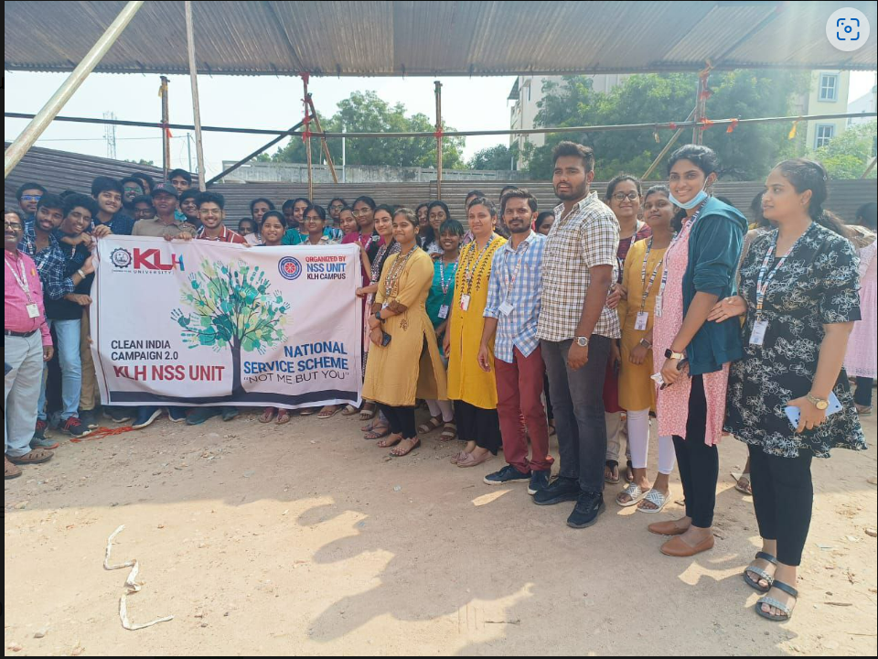

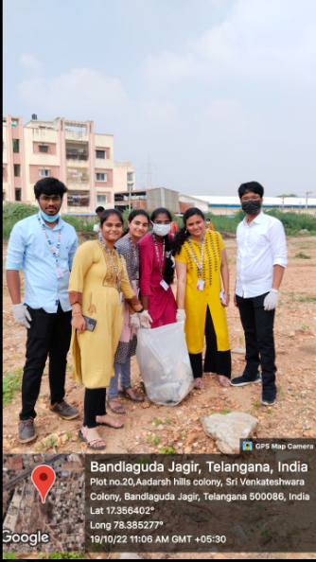 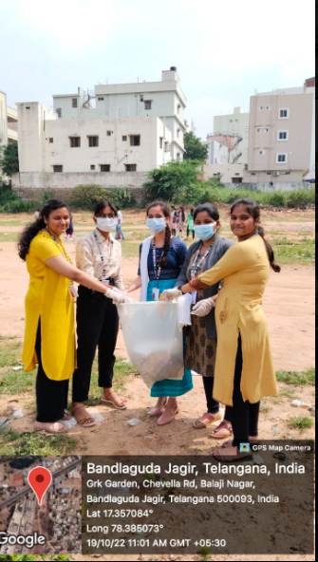

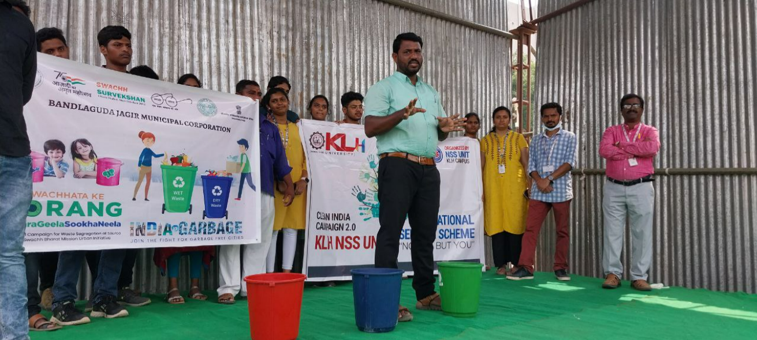 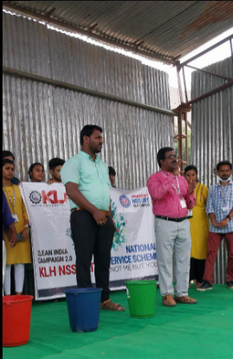

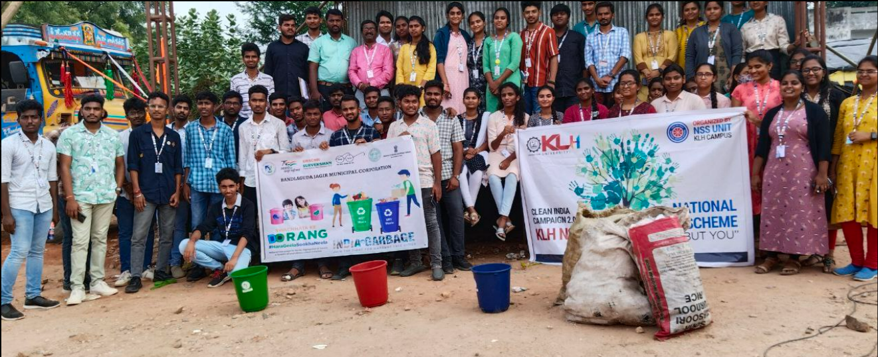

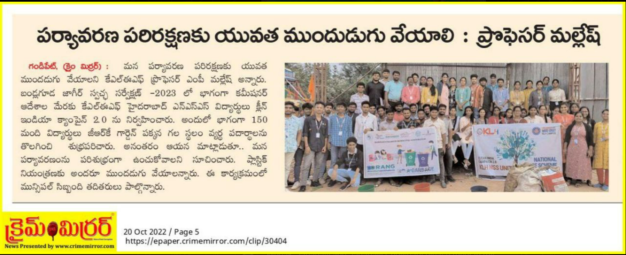

**STUDENTS PATICIPATION LIST**

